Roll No - 18
Srn no- 201700110
Name- Kunal Agarwal
Experiment No - 1
Aim - Installation and configuration of Hadoop ecosystem.

Steps:

Step 1 - Install the setup files



Step 2 - Extract the files

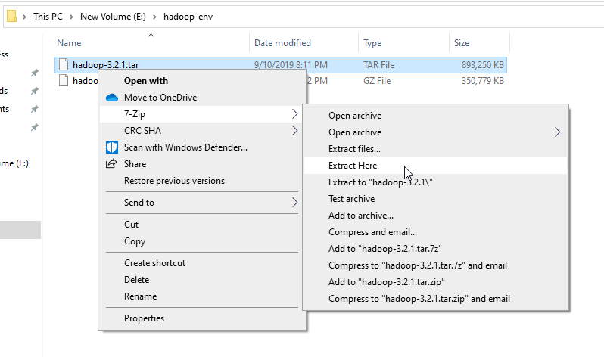

Step 3 - Setting up environment variables

1 - JAVA_HOME

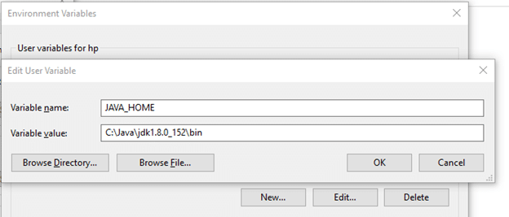

2- HADOOP_HOME

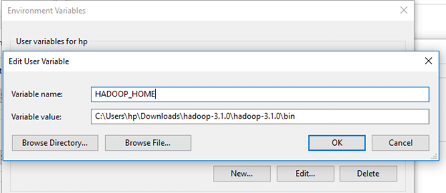

Step 4 - Click on New and add the bin directory path of Hadoop and Java in it.
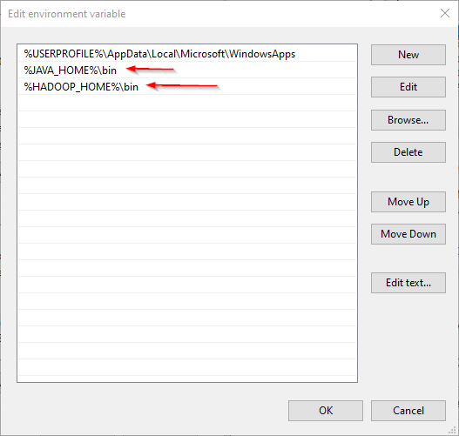

Step-5 Create a folder ‘data’ in the hadoop directory

- Create a folder with the name ‘datanode’ and a folder ‘namenode’ in this data directory

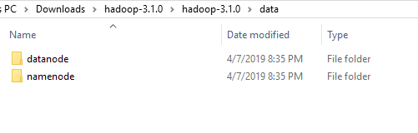
Step-6 Configuring Hadoop cluster

- Now, let’s open “hdfs-site.xml” file located in “%HADOOP_HOME%\etc\hadoop” directory, and we should add the following properties within the <configuration></configuration> element:

<property>
<name>dfs.replication</name>
<value>1</value>
</property>
<property>
<name>dfs.namenode.name.dir</name>
<value>file:///E:/hadoop-env/hadoop-3.2.1/data/dfs/namenode</value>
</property>
<property>
<name>dfs.datanode.data.dir</name>
<value>file:///E:/hadoop-env/hadoop-3.2.1/data/dfs/datanode</value>
</property>

- Now, we should configure the name node URL adding the following XML code into the <configuration></configuration> element within “core-site.xml”:

<property>
<name>fs.default.name</name>
<value>hdfs://localhost:9820</value>
</property

- Now, we should add the following XML code into the <configuration></configuration> element within “mapred-site.xml”:

<property>
<name>mapreduce.framework.name</name>
<value>yarn</value>
<description>MapReduce framework name</description>
</property>

- Now, we should add the following XML code into the <configuration></configuration> element within “yarn-site.xml”:

<property>
<name>yarn.nodemanager.aux-services</name>
<value>mapreduce_shuffle</value>
<description>Yarn Node Manager Aux Service</description>
</property>

Step-7 Now, we will open Command Prompt, and navigate to “%HADOOP_HOME%\sbin” directory. Then we will run the following command to start the Hadoop nodes:

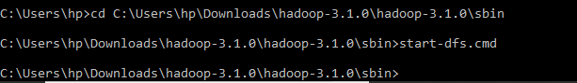

Two command prompt windows will open (one for the name node and one for the data node) as follows:

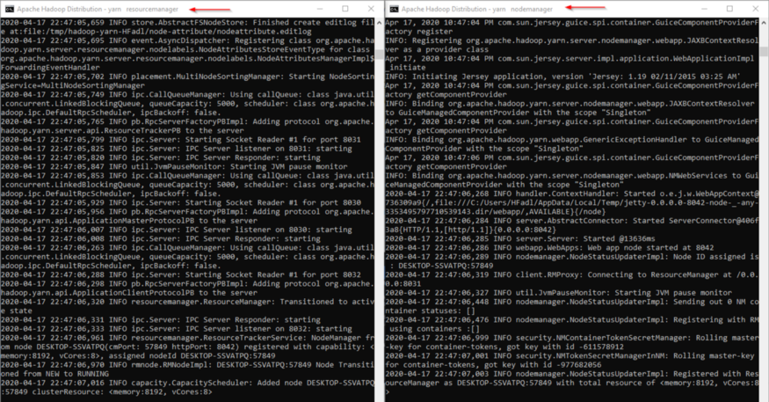

Conclusion: We have successfully installed the hadoop.

